Cloud Computing Experiment – 4

Question:
Create a simple cloud software application for Car Booking Reservation System using any Cloud Service Provider to demonstrate SaaS.
Answer:
AIM: To create a Car Booking Reservation System as a cloud-based SaaS application using Zoho Creator.
PROCEDURE:
Open Zoho Creator and start a new app.
- Make a Car Details form to store car info and availability.
- Make a Customer Details form to keep customer info.
- Make a Booking / Reservation form and connect cars and customers with lookup fields.
- Add workflows to calculate booking charges.
- Add workflows to update booking status.
- Publish the app so people can use it online.
IMPLEMENTATION:

Car Booking Reservation System

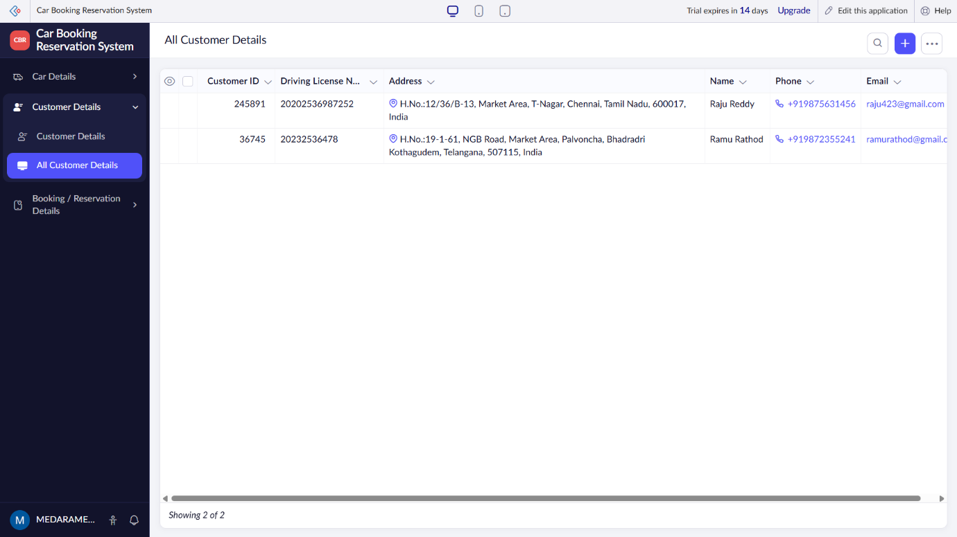

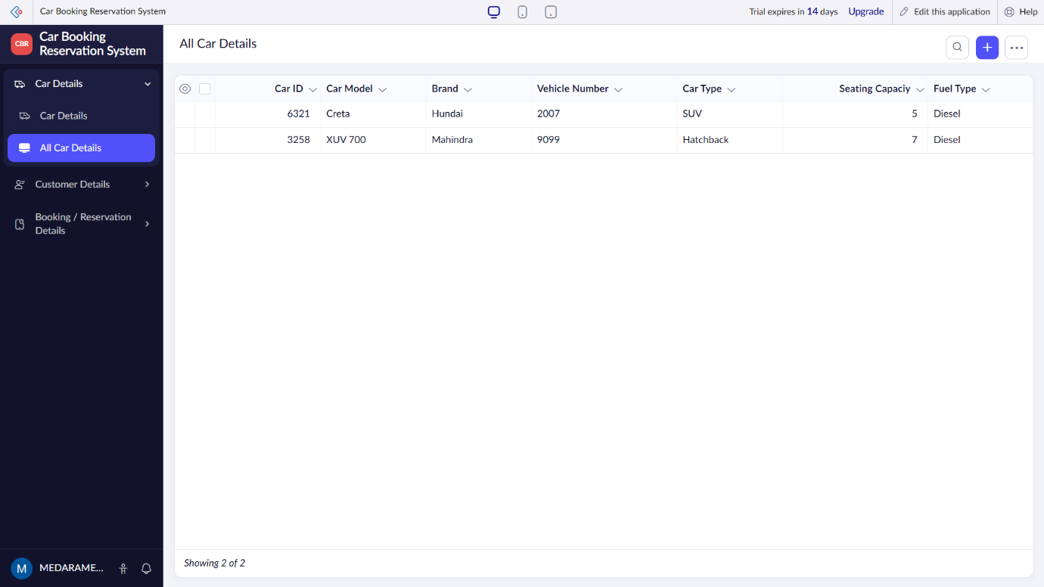
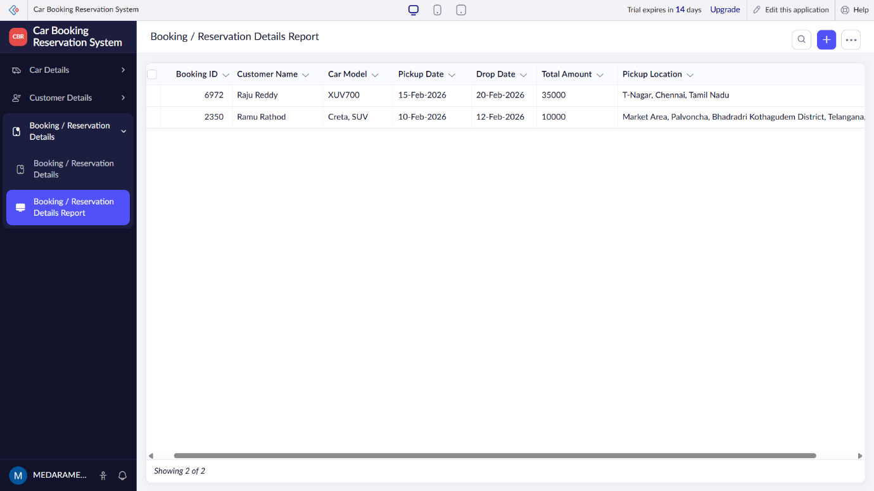

RESULT: A cloud-enabled Car Booking Reservation System is successfully created as a SaaS application, allowing users to reserve cars online.

